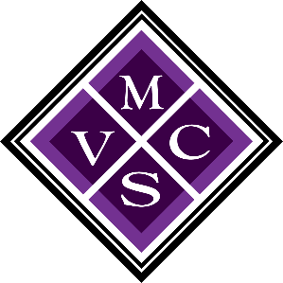
Mesa Valley Community School
MVCS Board of Directors
December 11, 2023
Mesa Valley Community School
10:45 AM (Virtual Meeting)

ATTENDANCE:
The meeting was called to order by President Nathan Brantley at 10:45 AM

Board Members Present: Nathan Brantley, Kalista Wickham, and Audrey Somerville

Administration/Staff Present: Director Laurajean Downs, Assistant Director Kami Costello, and Business Manager Julie Hoge

APPROVAL OF AGENDA:
APPROVAL OF AGENDA:
Single item agenda approved as presented.
COMMUNICATIONS:
COMMUNICATIONS:
No comments were given.
FACILITY/FINANCE:
FINANCE/FACILITY:
Business Manager, Julie Hoge, asked that the board approve the yearly audit report.

“Moved by Audrey Somerville, supported by Kalista Wickham, that the audit report for fiscal year 22.23 be approved as presented.”

Roll Call Vote:
Ayes: Kalista Wickham, Audrey Somerville, Nathan Brantley
Nays: None
OTHER MATTERS:
OTHER MATTERS:
Future Meetings – The next regular board meeting will be held on January 22, 2024.
ADJOURNMENT:
ADJOURNMENT:
The meeting adjourned at 11:01 AM.

